Assimilate is Sennheiser’s Latest ‘AMBEO for VR’ Software Partner

Wedemark/Las Vegas, April 9, 2018 – VR post-production software company, Assimilate, has joined Sennheiser’s AMBEO for VR partnership program. Its SCRATCH VR live streaming and post-production software can accept direct feeds from the Sennheiser AMBEO VR Mic. This ensures simpler, quicker, and high-quality workflows for VR video creators.

“Sennheiser is happy to welcome Assimilate to the partnership program,” said Véronique Larcher, AMBEO Immersive Audio co-director at Sennheiser. “With the AMBEO A-B converter integrated into SCRATCH VR, this post-production software enables simplified, high-quality VR audio input and editing for video-editing professionals from the comfort of a tool they are familiar with.”

“We seek to partner with companies that offer the best in VR tools and resources to creative professionals,” said Jeff Edson, CEO at Assimilate. “Sennheiser is known for its high-quality microphones and adding its immersive audio capability with the AMBEO VR Mic will further enhance creating impactful VR experiences in SCRATCH VR.”

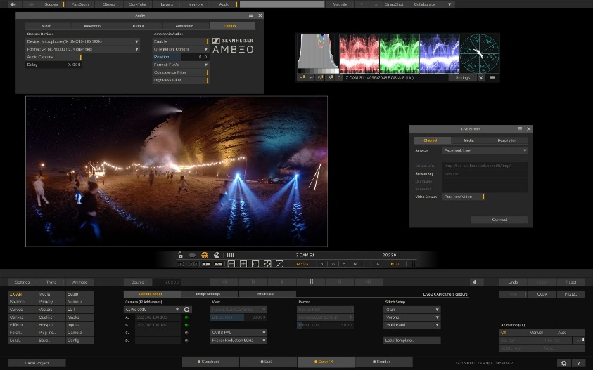 | Assimilate’s SCRATCH VR includes the AMBEO A-B converter and can be directly fed the A-format Ambisonics audio stream from the AMBEO VR Mic.  

SCRATCH VR
Creating VR360 / 3D and VR180 / 3D experiences requires focused attention to complex details and most usually fast time-to-market. SCRATCH VR 9.0 greatly simplifies the VR post-production process with one-stop shopping – a single, streamlined VR workflow that includes all the needed functions for creating impactful VR180 and VR360 experiences – saving enormous amounts of time, hassles, and money. SCRATCH VR 9.0 workflow includes all the necessary VR post-production tools, from preview, to data management, dailies, stitching, color grading, compositing, Sennheiser AMBEO audio, playback, cloud-based reviews, finishing, and mastering.

Visit Sennheiser and Neumann at NAB, April 9 to 12, Central Hall, Booth 1307.
Visit Assimilate at NAB, April 9 to 12, at B&H, Booth SL2916 and Z CAM, Booth C1052

About Assimilate
Assimilate provides real-time post-production tools and workflows that have proven essential to productivity and creativity in the creation of 2D/3D/VR studio and independent feature films, documentaries, TV episodes, and music videos. The Scratch product line equips directors, DPs, on-set DITs and post-production artists with the latest, state-of-the-art, cost-effective tools and workflows they need to simplify the post-production process and achieve high-quality results. Scratch is resolution independent, and continually updates support for nearly all formats. Additionally, in SCRATCH VR, Assimilate offers the only professional end-to-end VR workflow and tools for VR360 / 3D and VR180 / 3D – including stitching, Ambisonic sound, and live streaming. Assimilate partners with Z Cam to offer complete, integrated VR workflows with its SCRATCH VR and the Z Cam S1, S1 Pro, and K1 Pro VR camera – from previews to shoot, data management, stitch, color grading compositing, finishing, and mastering. Assimilate also partners with Sennheiser to include its world-class audio capability with its AMBEO A-B converter integrated in SCRATCH VR. Learn more at www.assimilateinc.com

Assimilate Contact

Aggie Frizell
aggie@assimilateinc.com
+1 425-503-3036

About Sennheiser
Sennheiser is shaping the future of audio – a vision built on more than 70 years of innovation culture, which is deeply rooted within the family-owned company. Founded in 1945, Sennheiser is one of the world’s leading manufacturers of headphones, microphones and wireless transmission systems. With 20 sales subsidiaries and long-established trading partners, the company is active in more than 50 countries and operates its own production facilities in Germany, Ireland and the USA. Sennheiser has around 2,800 employees around the world that share a passion for audio excellence. Since 2013, Sennheiser has been managed by Daniel Sennheiser and Dr. Andreas Sennheiser, the third generation of the family to run the company. In 2016, the Sennheiser Group had sales totalling €658.4 million. www.sennheiser.com

Local Contact Global Contact

Jeff Touzeau Stephanie Schmidt
jeff@hummingbirdmedia.com stephanie.schmidt@sennheiser.com
+1 (914) 602-2913 +49 (5130) 600 – 1275

